**CDS invoked ODATA QUERY Testing**

ODATA created for CDS View works based on SADL exposure and we don’t need to write any custom implementation for the Querying.

SADL – Service Adaptation Definition Language.

**1.Count Query**

**URI:** <http://172.35.0.26:8000/sap/opu/odata/sap/ZTRUPEN_ODATA_INVOKECDS_SRV/ZTRUPEN_SALES_ORDER('0000001946')/to_ITEM/$count>

**Output**

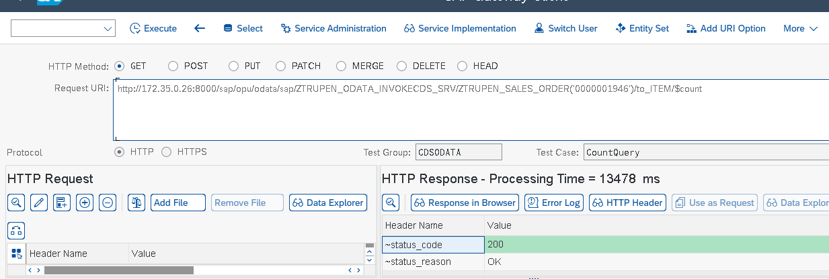

**2.Expand Query**

**URI:** <http://172.35.0.26:8000/sap/opu/odata/sap/ZTRUPEN_ODATA_INVOKECDS_SRV/ZTRUPEN_SALES_ORDER('0000001946')?$expand=to_ITEM>

**Output**

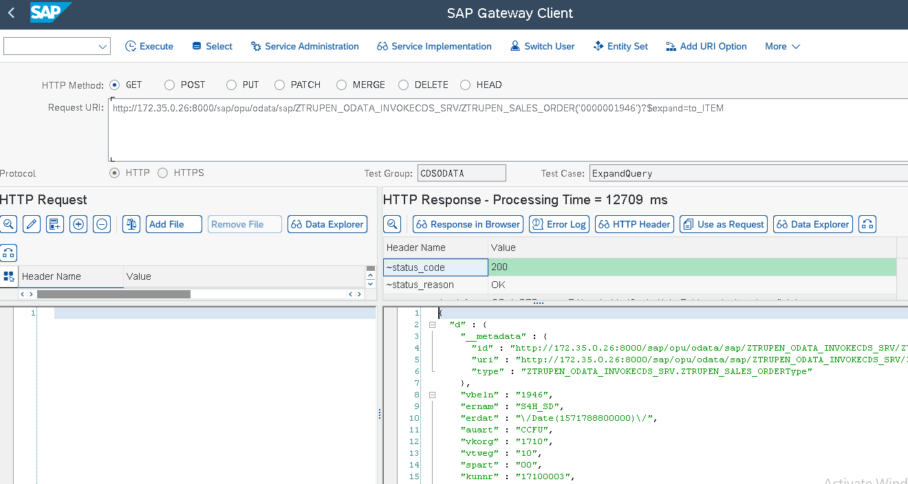

**3.Filter Query**

**URI** http://172.35.0.26:8000/sap/opu/odata/sap/ZTRUPEN_ODATA_INVOKECDS_SRV/ZTRUPEN_SALES_ORDER?$top=10&$filter=ernam eq 'SERV_MAN'

**Output**

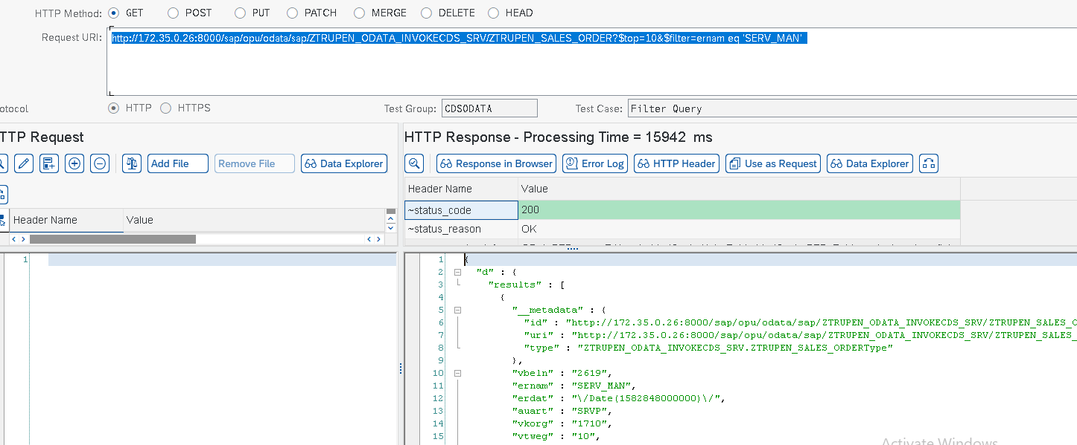

**4.FORMAT Query:**

**URI** <http://172.35.0.26:8000/sap/opu/odata/sap/ZTRUPEN_ODATA_INVOKECDS_SRV/ZTRUPEN_SALES_ORDER?$format=json>

**Output**

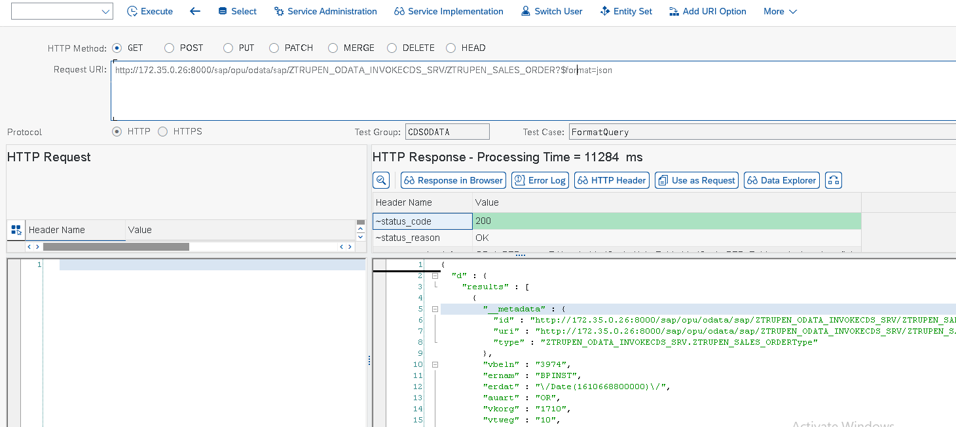

**5.INLINE COUNT Query**

**URI**

http://172.35.0.26:8000/sap/opu/odata/sap/ZTRUPEN_ODATA_INVOKECDS_SRV/ZTRUPEN_SALES_ORDER?$top=10&$filter=ernam eq 'SERV_MAN'&$inlinecount=allpages

**Output**

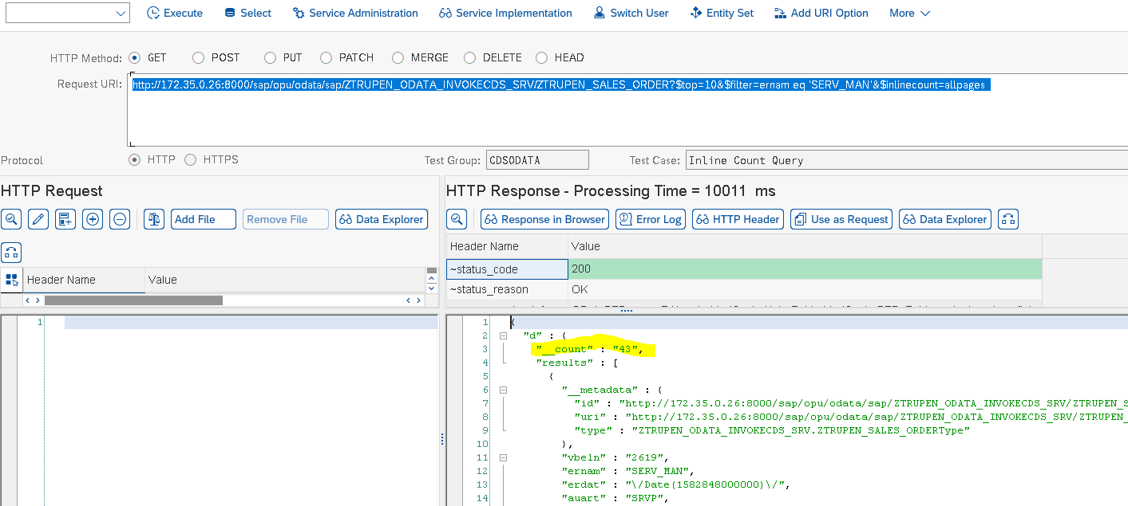

**6.Links Query**

**URI** <http://172.35.0.26:8000/sap/opu/odata/sap/ZTRUPEN_ODATA_INVOKECDS_SRV/ZTRUPEN_SALES_ORDER('0000001946')/$links/to_ITEM>

**Output**

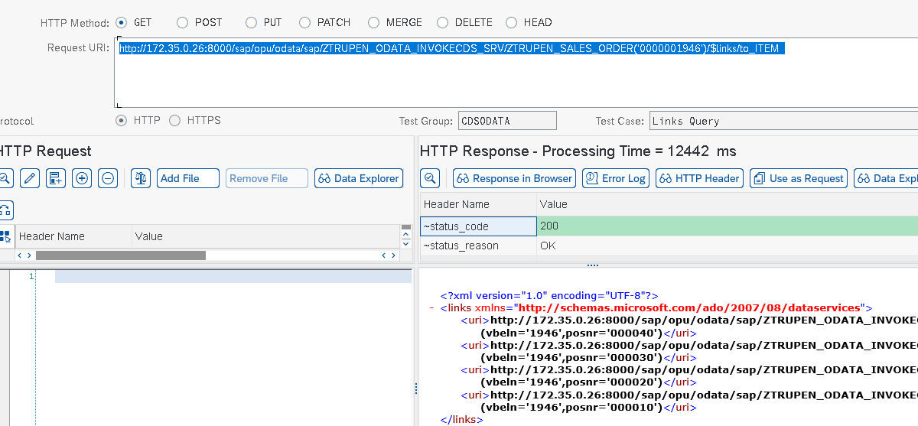

**7.ORDER BY Query**

**URI** http://172.35.0.26:8000/sap/opu/odata/sap/ZTRUPEN_ODATA_INVOKECDS_SRV/ZTRUPEN_SALES_ORDER?$top=10&$orderby=vbeln desc

**Output**

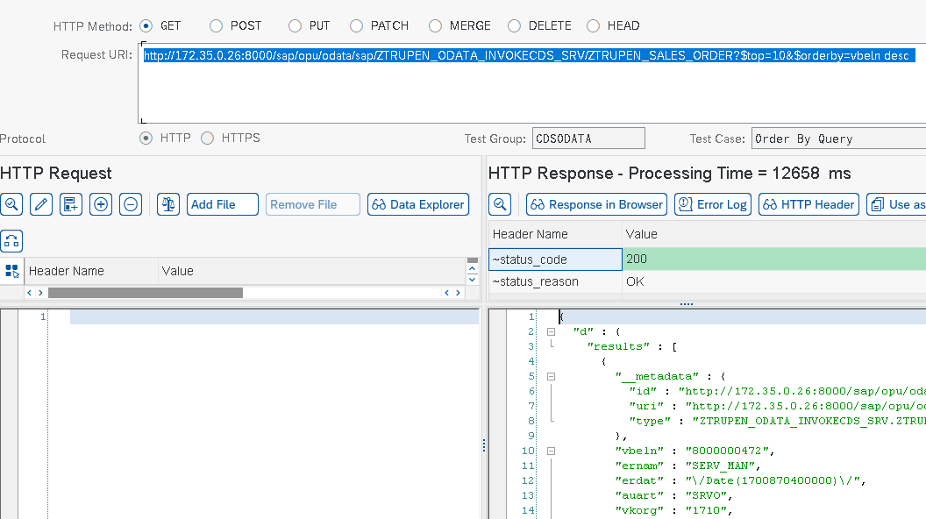

**8.SELECT Query**

**URI**

http://172.35.0.26:8000/sap/opu/odata/sap/ZTRUPEN_ODATA_INVOKECDS_SRV/ZTRUPEN_SALES_ORDER('0000001946')?$select=vbeln , ernam

**Output**

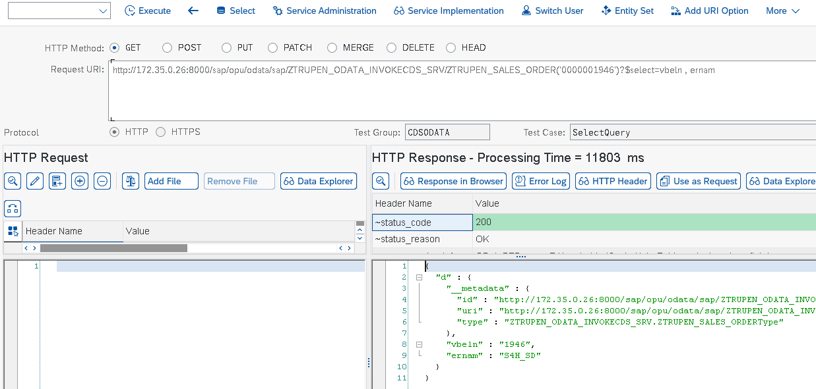

**9.SKIP Query**

**URI** http://172.35.0.26:8000/sap/opu/odata/sap/ZTRUPEN_ODATA_INVOKECDS_SRV/ZTRUPEN_SALES_ORDER?$top=10&$filter=ernam eq 'SERV_MAN'&$skip=2

**Output**

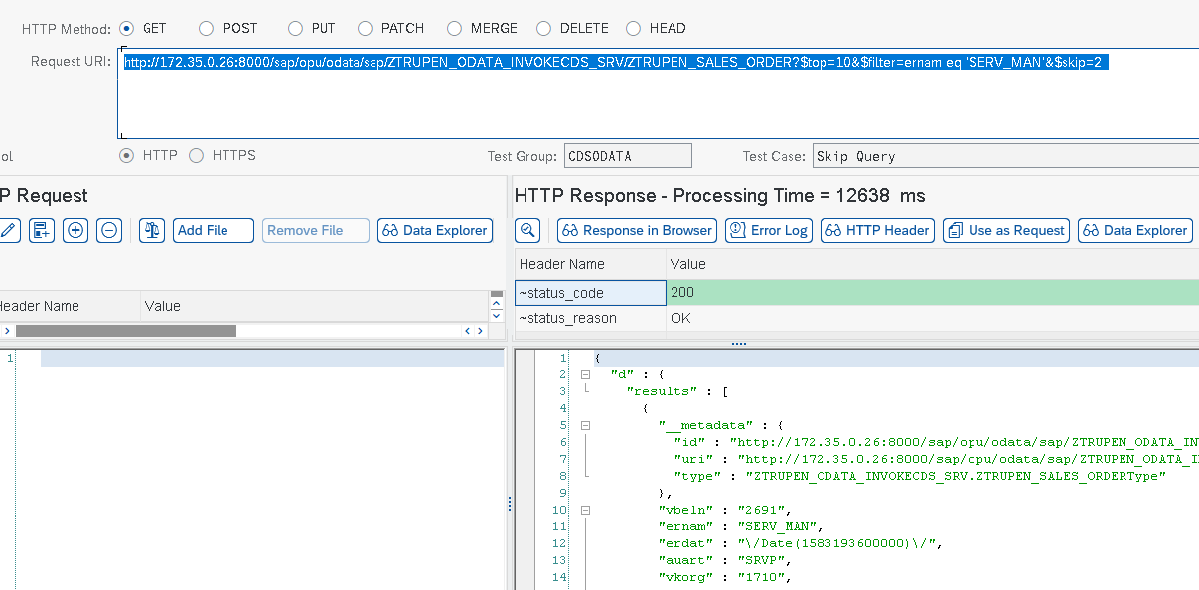

**10.Top Query**

**URI**

<http://172.35.0.26:8000/sap/opu/odata/sap/ZTRUPEN_ODATA_INVOKECDS_SRV/ZTRUPEN_SALES_ORDER?$top=10>

**Output**

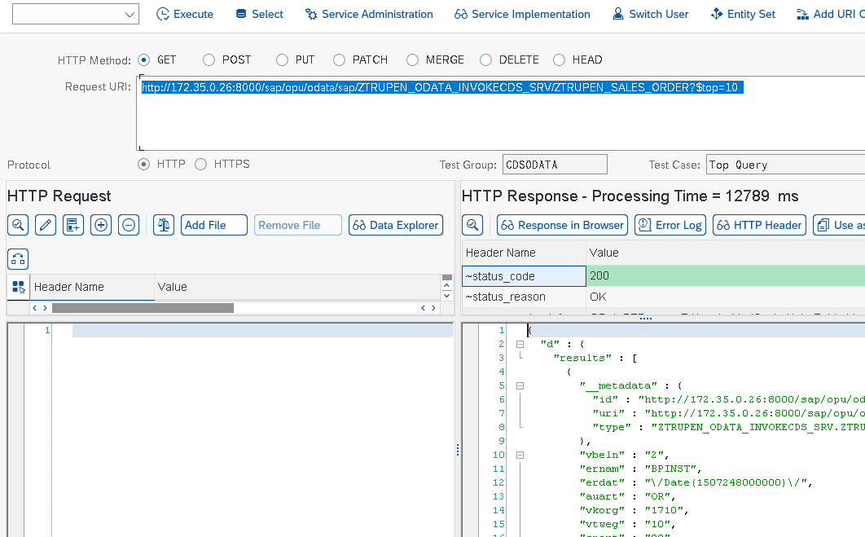

**11.Value Query**

**URI**

<http://172.35.0.26:8000/sap/opu/odata/sap/ZTRUPEN_ODATA_INVOKECDS_SRV/ZTRUPEN_SALES_ORDER('0000001946')/ernam/$value>

**Output**

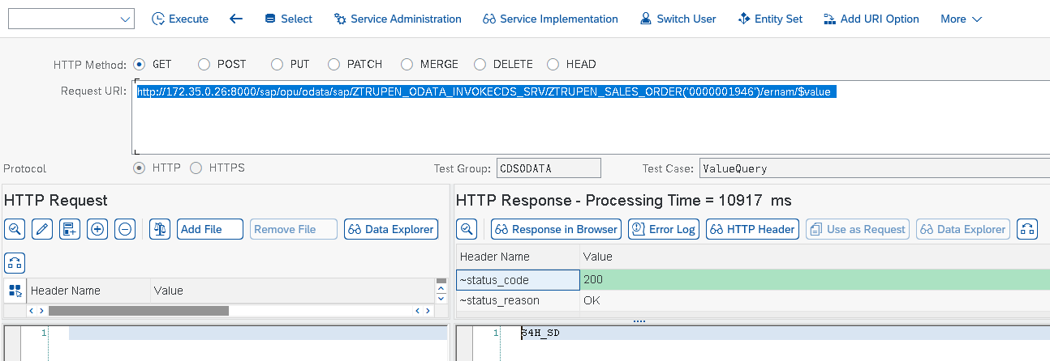

Manual ODATA Creation without any CDS View Requires Custom Logic Implementation for Handling certain Queries and to provide results.

1. $orderby
2. $top
3. $skip
4. $filter
5. $inlinecount